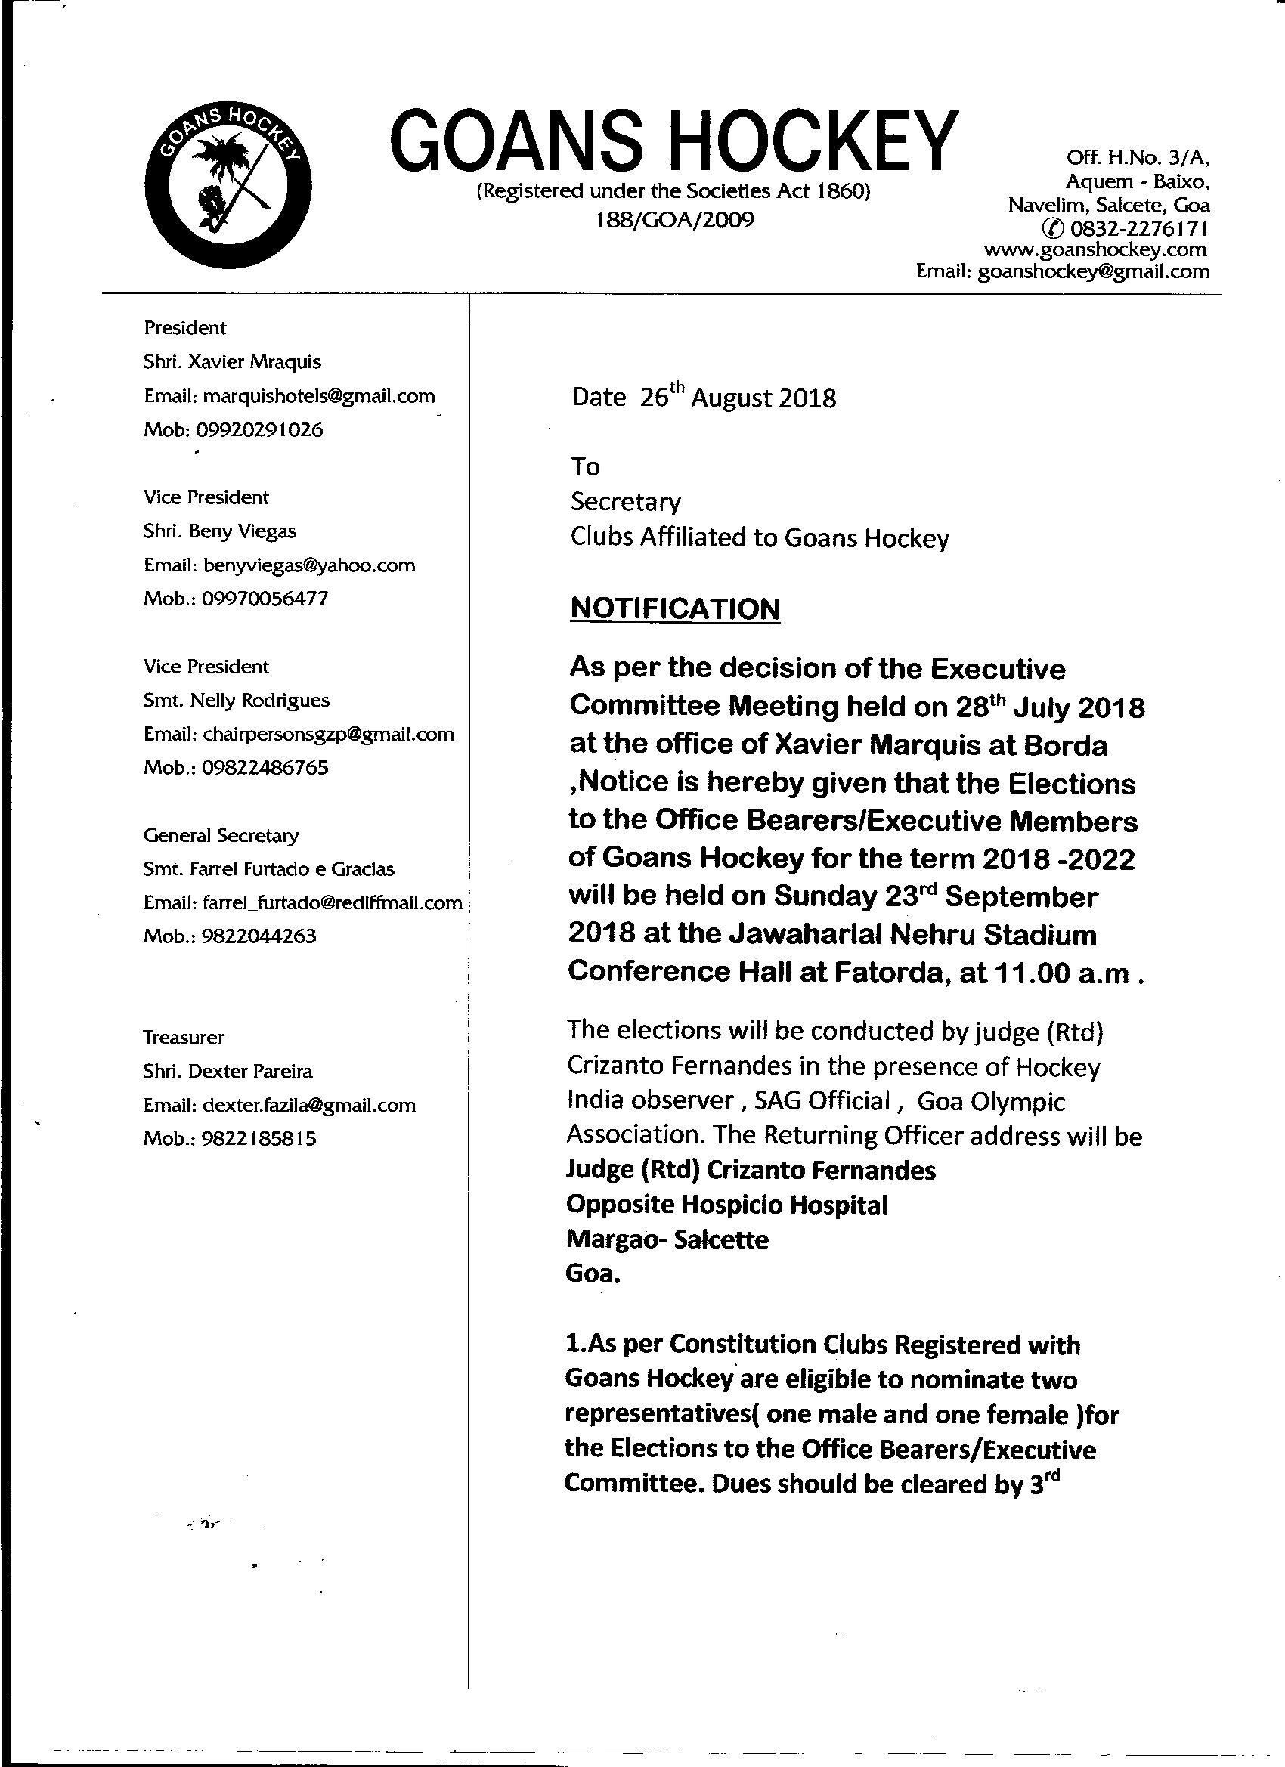
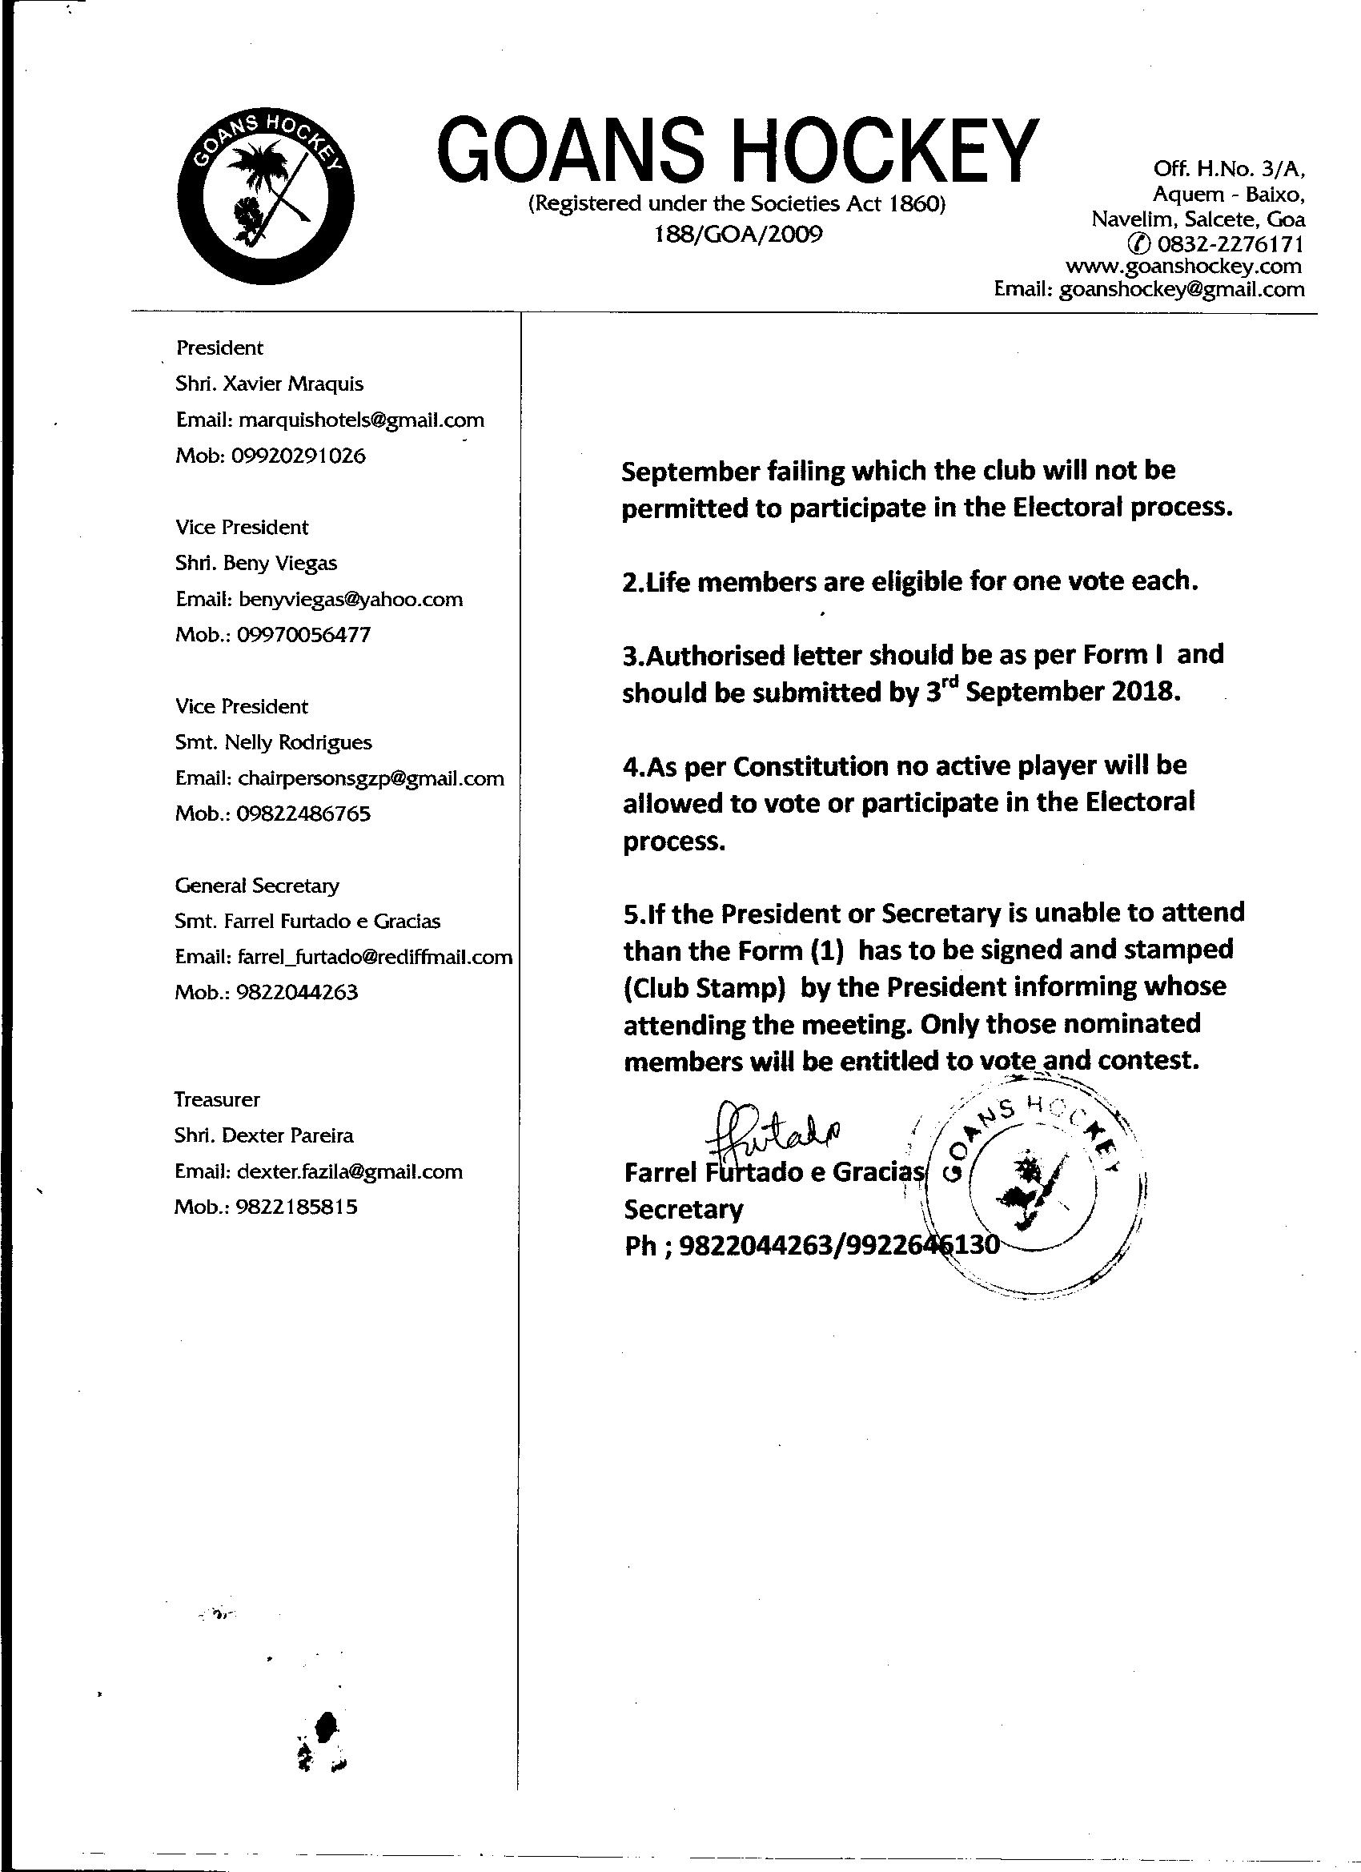

FORM I
GOANS HOCKEY ASSOCIATION ELECTORAL LIST
ANNUAL GENERAL BODY MEETING ON SUNDAY 23RD SEPTEMBER 2018
ELECTIONS TO OFFICE BEARERS 2018- 2022 AUTHORISED REPRESENTATIVE
TO BE SUBMITED BEFORE 3RD SEPTEMBER 2018

NAME OF THE AFFILIATED CLUB;…………………………………………………………

1.DELEGATE (1)-------------------------------------------------(Photo)

2.DELEGATE (2)---------------------------------------------------(photo)

SIGNATURE OF PRESIDENT SIGNATURE OF SECRETARY
SEAL

The club who is affiliated to the Goans Hockey should submit the Form 1 to the Secretary of Goans Hockey Farrel Furtado e Gracias by 3rd September by e mail farrel_furtado@rediffmail.com and the original hard copy should be submitted by 14th September to the returning officer in person . Judge (Rtd) Crizant Fernandes , Opposite Hospicio, Margao –Salcete-Goa.

Farrel Furtado e Gracias
Secretary
FORM II
Election of the Office Bearers and members of the Executive Council of Goans Hockey 2018- 2022

NOMINATION PAPER FOR
(To be submitted on or before 14th September2018
Election As-----------------------------------------------------------------------------------------------(Name of the Post)
To
The Returning Officer for the above Election
Goan Hockey

We nominate Mr./Mrs./ Ms.

(Name & Address) whose name is entered at Sl.No. …………………in the Electoral College list for the above mentioned post.
Our particulars are given below:
 | Name of Candidate | Name of affiliated Club | Sl.No in the Electoral College list | Signature
Proposer

Seconder

I, the Candidate above named do hereby give my assent to my nomination for the above Post.
Name of the Candidate………………………………………………………..
Name of the Club………………………………………………………………….
Sl.No.in the Electoral College List
Signature
FORM II
GOANS HOCKEY ASSOCIATION
Election of the office Bearers and members of the Executive Council of Goans Hockey for 2018-2022
Notice of Withdrawal of candidate for Election as
………………………………………………………
(Name of the Post)
To
The Returning Officer

I, the validly nominated candidate , do hereby give my notice of withdrawal of candidature for the above post.

(Name and Address)whose name is entered at Sr No………………….in the Electoral College list for the above mentioned post.
……………………………………………………………………………………………………

Name of Candidate :,,,,,,,,,,,,,,,,,,,,,,,,,,,,,,,,,,,,,,,,,,,,,,,,,,,,,,,,,,,,,,,,,,,,,,,,,,,,,,,,,,,,,,,,,,,,,,,,,,,,,,

Name of the unit / Club………………………………………………………

Sr.No in The Electoral list:…………………………....................................
Signature
Date
Place
OFFICE OF THE RETURNING OFFICER

In Continuation of the Notification dated 26th August 2018 issued by the Secretary of Goans Hockey ,now being the Returning Officer ,I have fixed the following schedule for the Elections of the Office Bearers and the Executive Council of Goans Hockey.
Particulars | Dates | Time
Notice issued to all affiliated Members for nomination to Electoral list form I, Nomination Form II and Withdrawal forms III to be sent by members | 26th August 2018 | 5.00p.m
Last date for for Submission of Names of Authorised representatives (Electoral College) | 3rd September 2018 | 5.00p.m
Publication of Electoral College /authorized representatives | 6th September 2018 | 5.00p.m
- Submission of Nomination Papers.Please Note:The nomination paers are to be delivered himself/herself by the candidate to the Returning Officer in person. | 14th September 2018 | 5.00p.m
Scrutiny of Nominations of list of valid nominated candidates | 15th September 2018 | 4.00 t0 5.00p.m  Notification of list by 6.00p.m
Withdrawal of nomination (in Person ) | 18th September | 4.00 to 5.00p.m
Publication of Final list of valid Nominations after withdrawal | 19th September 2018
Elections | 23rd September 2018 | 11.a.m
Judge Rtd (Crizant Fernandes)

